tHE CALENDAR TECHNOLOGY OF A HYBRID WAR
Miloš Milovanović
Mathematical Institute of the Serbian Academy of Sciences and Arts, Belgrade, milosm@mi.sanu.ac.rs

Abstract: The author considers significance of the calendar issue in hybrid warfare. It is regarded to be a cyber technology of sacred origin, which should indicate sonorous names such as Gregorian, Julian, and Nicaean etc. Calendar concerns the memory matrix which is a base of the conscious life. Breaking its structure is therefore a chronological attempt that immediately hits consciousness. The issue has come especially momentous in Postmodern Era which is characterized by an emergence of the novel structure via collapsing of neoliberal democracy. A paradigmatic shift is manifested in the absolute mythology restoring a memory matrix
Keywords: calendar issue, absolute mythology, memory matrix, Postmodern Era, paradigmatic shift.

1. introduction
The definition of war concerns a policy continuation by the military mean [1]. In that respect, the hybrid warfare which was proposed by Frank Hoffman is considered to be an integral concept of the war [2]. If taken into account that the policy is a surrogate for mythology according to Claude Lévi-Strauss, the conclusion followed should become self-evident [3].
An effecious designation of the myth is presented by Aleksei Losev in the conception of an unfolded magic name [4]. It implies a mythical substance that is unfolding via the temporal organization which comes to be a crucial item. Losev has moreover conceptualized the absolute mythology that is a categorical skeleton, which menas that every myth should embed into. Such a mythology is presented by Christianity in respect to the Orthodox icon which has temporally organized [5].
In that regard, the absolute myth concerns the ecclesial calendar which is the ultimate reach of the iconography [6]. It should constitute a memory matrix in terms of the time continuum that is a primordial intuition of consciousness [7]. Breaking the calendar structure is therefore a chronological attempt that completely hits the conscious life [8]. Numerous instances on the topic indicate it to be a cyber technology of the hybrid war in a real sense. A cognition of the technology allows for its use in both offensive and defensive mean.
After introductory section, the next considers a sacred origin of the calendar issue. In the third section, one should elaborate a usage of the cyber technology in a hybrid warfare. The fourth section concerns Postmodern Era which is characterized by an emergence of the novel structure via collapsing of neoliberal democracy. The last contains concluding remarks.

2. ORIGIN OF THE CALENDAR
Since ancient ages, the calendar has been an issue of the sacred origin [6]. Sonorous names such as Gregorian, Julian and Nicaean etc. should indicate a vocation which was involved in its constitution. Gregory XIII has got the title of pontifex optimaximus for merits of the calendar reform (Fig. 1), which is a double superlative that means him to be the pope over popes (Lat. optimus – best, maximus – biggest). Julius Caesar had been promoted to the sacred vocation of pontifex maximus before he dealt in calendar (Lat. pontifex – bridgebuilder). The First Ecumenical Council of Nicaea has foundated the Passover rule of the ecclesial calendar (Fig. 2). Such instances imply an origin of the calendar issue which is related to unfolding of a mythical substance [8].
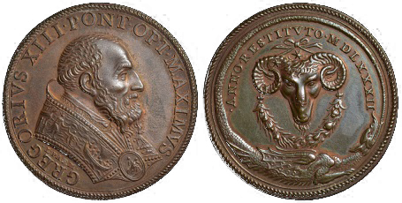
Figure 1. Medallion of pontifex optimaximus which is assigned to Greory XIII for merits of the calendar reform
An establishment of the Julian calendar coincides to a transformation of the Roman Republic into empire. It presented a continuation of the Egyptian Empire whose astronomer was Sosigenes of Alexandria that had established the solar claendar of Rome. In that regard, the reform which was implemented by Julius Caesar concerns an emergence of the novel structure that should correspond to a monarchist order [6].
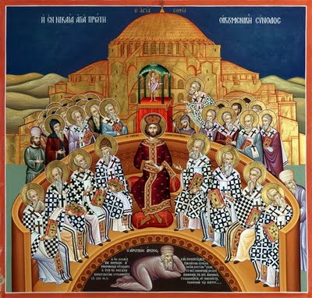 Figure 2. The First Ecumenical Council of Nicaea which has foundated the Passover rule of the ecclesial calendar
But the Republic didn`t cease to exist, as well as its calendar which had been a lunisolar system. It was incorporated into the Roman Empire by a virtue of the confusion year providing continuity of a myth that was evident in terms of months, most of which had designated after gods of Rome. The Julian calendar has therefore proven widespreadly applicable in dating historical events, even those that had actually happened before it was constituted.
The ecclesial calendar has already restored a lunisolar system in the view of a Passover rule which is followed by the Orthodox Church. The rule has involved both the Tropical and the Siderial Zodiac in terms of the Passover equinox corresponding to the Julian date of March 22nd. In that respect, Zodiacal language of the calendar is regarded to be a primordial astrosymbolism relating the absoulte mythology of Christianity [6].
On the other hand, the Gregorian reform which was installed in the 16th century identified the Tropical equinox with March 21st which had coincided to its date during the First Ecumenical Council of Nicaea. It is the manner in which the calnedar has torned away from the Passover rule, reducing to the solar cycle of the Tropical Zodiac that aleniates from the primordial astrosymbolism.
In that regard, the Gregorian calendar initiates a secular modernism which is manifested by the elimination of time [8]. A crucial manifestation concerns the Common Era which is a linear model of the history that is deprived of any orientation or innovation. The memory matrix is therefore reduced to a mere historiography which has nothing to do with consciousness [8].
Immediately after the reform was announced, Gregory XIII sent his envoys in Constantinople to present rich gifts to the Patriarch Jeremiah II, including a suggestion to adopt the new style. On that occasion, it was convened the Council of Orthodox Churches which pronounced an anathema concerning the calendar issue. The decision signed by the Patriarch of Constantinople, Alexandria and Jerusalem was communicated to all the churches, the Venetian Doge Dacontius, the Pope Gregory XIII and others [10].
The same rejection has been stated again several times during centuries followed, which is a testimony of frequentative pressures the Orthodox Church was exposed to. Breaking of the Ottoman Empire which began at the end of the 17th century, such pressures fell on the Serbian people as well. In 1690, the Holy Roman Emperor Leopold I issued a decree termed Privilege which accepted demands of Serbs, guaranteeing religious freedom, an old-style calendar and the election of priests in a Roman Catholic state that did not support heterodoxies. But already in 1692, he tried a persuasion to adopt the Gregorian calendar which was successfully refused [11].
In 1814, the Austrian Emperor Franz I, sent intimatum to Stephen Stratimirovich, asking him for an advice on when and how to induce the Gregorian calendar among Serbs. The Metropolitan replied him in Latin, thoroughly proving an impossibility of the Orthodox Church to adopt new style [12]. Such a request was repeated again in 1825 as well as in 1844, being suspended due to strong opposition of Serbian bishops [13].

3. calendar in Hybrid warfare
The Gregorian calendar was received by Russia in 1918 after the October Revolution. In 1919, it was adopted as well by the Kingdom of Serbs, Croats and Slovenes. Breaking the monarchist tradition is pretty obvious in both instances. Alexander the First of Yugoslavia was not a Serbian monarch since neither the Patriarch crowned him, nor did him regarded himself to be a Serbian king but the governor of a Yugoslav nation that was formatted via unification of three peoples and three faiths [6].
In such an occasion after the First World War, the calendar issue is reconsidered among Orthodox peoples under a secular government. Other countries have also adopted the new style, wherein Bulgaria took a lead receiving the Gregorian calendar in 1916 immediately after Serbia was occupied. The war began by declaration of Austro-Hungary against Serbia, which had been following different styles. A trigger was the assassination of Archduke Franz Ferdinand which happened on an ecclesial feast [14]. It had been the Kosovar Martyrs` Day which was also the date of the Versailles Treaty that recognized the Kingdom of Serbs, Croats and Slovenes.
The disappearance of Yugoslavia was related to the Gazimestan meeting that occurred on its anniversary in 1989. Some intermediate events that also occurred on the same date were about the Constitution of Serbs, Croats and Slovenes in 1921 and the Cominform Resolution in 1948 which were cardinal for the Yugoslav history [6]. Vladimir Dedier has stated that in the hybrid war of the Bolsheviks against the Titoists, each anti-Titoist act was passed on a significant date of Serbian history [15]. Encountering the perspective of systemic constellations developed by Bert Hellinger, Anngwyn St Just remarked some mysterious facts about traumatic events which occur on anniversaries of previous ones, have a transgenerational character and relate according to synchronicity [16]. She observed a fractal coherence that connects nations to some areas and patrimonies, which required a sophisticate treatment for their healing [17].
In terms of Yugoslavia, the calendar is regarded to be a historical marker relating its integration and disintegration. After the First World War, the common state adopted the Gregorian calendar that had never been used in the Orthodox Church. Such a deflection from the memory matrix was particularly evident after the Second World War, since ecclesial feasts had lost their significance. On the other hand, the Serbian state which emerged through disintegration of Yugoslavia celebrates all holidays according to the ecclesial calendar except international festivals of January ½ and May ½.
The Serbian Statehood Day is the feast of Candlemas when the First Insurrection of Serbs against the Ottoman Empire began [18]. The Uprising Day of Serbia in the Yugoslav period was the Nativity of John the Baptist when it began the revolt against occupation during the Second World War. In that regard, Frances Yates pays a peculiar attention to memorization by the use of Zodiac which makes the calendar to be a memory matrix [19]. The Allied bombing of Belgrade on Easter might be considered in the same manner, as well as the Battle of Moikovace on Christmas and of Koshare which began on Good Friday. The Great Massacre in Shushniar over 5500 Serbs and 50 Jews was also implemented form the feast of Fiery Mary till St Elijah`s Day.
Fidelity to the old style concerns therefore a continuity of the history. An instance is the church in Ukraine, which has adopted the Gregorian calendar after a separation from the Russian Orthodox Church. The separation was blessed by the Patriarchate of Constantinople which had also adopted the new style after the First World War.
In the disappearance of Yugoslavia, the ecclesial calendar was discriminating belligerents. Within the Operation of Smolucha, a Serbian enclave that was besieged by Muslims has confirmed the identity in a telephone communication to the Srpska Army presenting dates of ecclesial feasts. The Dayton Agreement which has recognized the Republic of Srpska was reached on Synaxis of the Archangel Michael which had also been the holiday when the Serbian Army entered its capital in the First World War. Such instances elucidate significance of the calendar in hybrid warfare.

4. postmodern eRA
Secular modernism has eliminated time in a view of the Common Era which is a linear model of the history. Its adoption has proceeded gradually, which took full advantage during the 20th century. The old style has remained in the Russian as well as the Serbian Orthodox Church, on the area of Mount Athos, Jerusalem Patriarchate, among Copts, Armenians, Georgians and some peoples such as Chinese having own lunisolar systems [8].
Contrary to that, the 20th century has also indicated postmodern striving towards a restauration of the memory matrix [9]. The Brussels school of thermodynamics has developed the time operator formalism of complex systems [20]. According to such a view, system is termed to be complex if there exists the time operator corresponding to orientation and innovation. A paradigm of the theory is the three body problem Sun-Earth-Moon which concerns the Passover rule [6]. In that respect, it is manifested via the absolute mythology restoring a memory matrix [8].
The great alignment is an astronomical event that relates to the period from 1980 till 2016 when the solstice of the Tropical Zodiac coincided to the galactic equator (Fig. 3). The event has a mythological significance in terms of the Postmodern Era [8]. Above all, it concerns a fulfilment of the Mayan calendar which is a memory matrix that has not succumbed to the new style. In that respect, the Common Era is deconstructed by the alignment whereof numerous peoples have traditionally been aware [21].
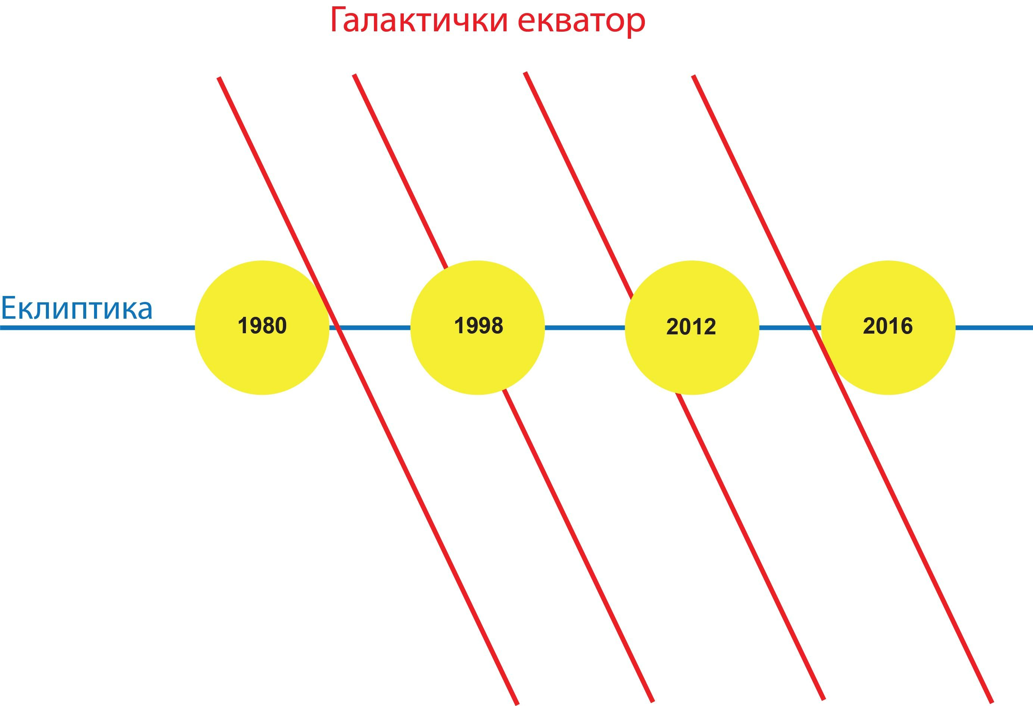
Figure 3. The great alignment from 1980 till 2016 when the solstice coincided to the galactic equator
Such an event is recognized as well in the ecclesial calendar via a coincidence of the solstice and Conception of St Anne, which should elucidate its significance [6]. Unlike the Gregorian calendar which has established a dominance of the Tropical Zodiac over the Sidereal one, it enables an establishment of the Calendar Zodiac which is a primordial astrosymbolism unifying both languages. In that regard, the epoch corresponds to the full moon on the eve of the solstice in 1980 when the great alignment took place. It has reconstructed the Passover rule and a memory matrix of the absolute mythology [8].
The novel structure emerging like that coincides to a collapse of neoliberal democracy in the 20th and 21st century. It is quite appropriate conception of a military regime which might be indispensable for its realization as well as in the Roman Republic. The hybrid war has therefore appeared an integral concept that governs the paradigmatic shift which is going on [22].

5. conclusion
The calendar is regarded to be a cyber technology of sacred origin, having the extreme significance in hybrid warfare. The issue has come especially momentous in a Postmodern Era that is characterized by the emergence of a novel structure via collapsing of neoliberal democracy. A military regime might be indispensable for its realization, as well as in the Roman Republic which became an empire due to the calendar reform.
A paradigmatic shift is manifested via the absolute mythology restoring a memory matrix, which relates to the conception of an unfolded magic name. In that respect, it should deconstruct the Common Era which is a linear model of the history deprived of any orientation or innovation. Such a model has been initiated by secular modernism corresponding to the Gregorian calendar.
The calendar has been a historical marker relating Yugoslavian integration and disintegration. The Serbian state which emerged through disintegration of Yugoslavia celebrates holidays according to the ecclesial calendar. In that regard, it follows up a memory matrix corresponding to continuity of the history which is concerned by Battles of Moikovac and Koshare etc.

References
- VON CLAUSEWITZ,C.: Vom Kriege, bei Ferdinand Dümmler, Berlin, 1832.
- HOFFMAN,F.: Conflicts in the 21st Century: The Rise of Hybrid Wars, Potomac Institute for Policy Studies, Arlington, 2007.
- LÉVI-STRAUSS,C.: The structural study of myth, The Journal of American Folklore, 68(270) (Oct.—Dec., 1955) 428—44.
- LOSEV,A.F.: Dijalektika mita, Zepter Book World, Beograd, 2000.
- ANTONOVA,C.: Space, Time and Presence in the Icon: Seeing the World with the Eyes of God, Routledge – Taylor & Francis Group, London – New York, 2010.
- MILOVANOVIĆ,M.: Pitanje kalendara u svetlosti predanja Srpske pravoslvne crkve, Metaphysica – Zlatno runo, Beograd, 2021.
- MILOVANOVIĆ,M.: Time and consciousness in intuitionism, Biosystems, under review.
- MILOVANOVIĆ,M.: Kalendarska hronologija povesti, Mitološki zbornik, under review.
- MILOVANOVIĆ,M.: Kalendarsko pamćenje: kontinuitet i značaj astrologije u predanju crkve, Zbornik radova Konferencije Razvoj astronomije kod Srba XI, Beograd 18—22. april 2021, Astronomsko društvo „Ruđer Bošković“, Beograd, 699—736.
- ANGELOV,K.: Stari kalendar i nauka, Crkva i vreme: o starom i novom kalendaru, Beograd, 2000, 53—94.
- J.C.: O reformi kalendara, Izveštaj o pravoslavnom bogoslovskom zavodu u Zadru 1899/1900, Štamparija Špira Artale, Zadar, 1900, 5—21.
- STRATIMIROVIĆ,S.: Carskomu Veličestvu, Serbski letopis, 27(88) (1853) 87—116.
- RUVARAC,D.: Pokušaj da Srbi pravoslavne vere usvoje nov – Gregorijev – kalendar, Srpski Sion: zvanični list Pravoslavnog srpskog arhijerejskog sinoda Mitropolije karlovačke za duhovne, crkvene i jerarhijske stvari, 15(8) (petak, 1. avgust 1905) 197—200.
- KISSANE,D.: The Balkan bullet with butterfly wings, CEU Political Science Journal, 1(4) (2006) 85—106.
- DEDIJER,V.: Izgubljena bitka J.V.Staljina, Svjetlost – Prosveta, Sarajevo – Beograd, 1969.
- HELLINGER,B.: Farewell: Family Constellations with Descendants of Victims and Perpetrators (C. Beaumont, Trans.), Carl-Auer-Systeme Verlag, Heidelberg, 2003.
- ST JUST,A.: Trauma and the Human Condition: Notes from the International Field, CreateSpace Independent Publishing Platform, USA, 2013.
- ŠARIĆ,Lj.: Serbia`s Statehood Day 2002—2010, Transforming National Holidays: Identity discourse in the West and South Slavic Countries, 1985—2010, John Benjamins Publishing Company, 2012, 35—56.
- YATES, F.: The Art of Memory, Routledge – Kegan Paul, London – New York, 1966.
- PRIGOGINE,I.: From Being to Becoming: Time and Complexity in the Physical Science, W.H.Freeman & Co., New York, 1980.
- JENKINS,J.M.: Galactic Alignment: The Transformation of Consciousness according to Mayan, Egyptian, and Vedic Tradition, Bear & Co., Rochester Vermont, 2002.
- MILOVANOVIĆ,M.: Geocentrisam and heliocentrism as opposed paradigmatic conceptions, European Journal of Science and Theology, 9(4) (August 2013) 31—45.

